# Premier+ Environment Setup

Contents

Premier+ Environment Setup 1

Overview 2

Application Components of Premier 2

Application Components of Premier Services 3

Application Components of Premier Tools 3

Prerequisite Software 3

NSB Persistence Databases 4

Visual Studio Solutions and Projects 4

Application Dependencies 5

Infrastructure and Application Setup 5

Windows Accounts 5

Databases 6

Databases – Existing 7

IIS 7

IIS – Existing 7

NServiceBus 7

NSB Handler Setup 11

Server Infrastructure 11

DEV1 12

DEV2 12

DIT1 12

DIT2 12

SIT G1 13

SIT G2 13

SIT G3 13

PERF 14

PROD 15

P80 16

P70 16

Elastic Search Setup 17

Deployment and Verification Checklist 21

# Overview

The new Premier application is comprised of new deployable components and also additions to the currently existing Premier UX applications. Figure 1 shows the deployable components of the overall solution along with some of the external dependencies. The light-blue shading represents a bounded context from the perspective of deployable components. The light green items represent existing applications and services. Note that more comprehensive diagrams are provided in separate documentation. Figure 1 is meant to simply provide context for this document.

This document contains setup and configuration information for the components supporting the new Premier application. Some of the information is not environment specific as it is assumed that each environment will be identical in terms of the features and software components needed to support the application.



Figure 1 - Deployment Components

## Application Components of Premier

Premier is a suite of web components and NServiceBus based components that provide end user functionality.

1. **Premier UX**. This is an ASP.NET MVC application to be hosted in IIS. It has dependencies on the Premier Data database.
2. **Premier Web API**. This is an ASP.NET Web API application to be hosted in IIS. It has dependencies on the Premier Services layer.
3. **Premier Data Database**. This is a SQL Server database containing the data used by Premier UX to render the screens. It is populated by the components of the Premier Services layer.

## Application Components of Premier Services

Premier Services is a suite of NServiceBus based components that aggregate the data to be used by the Premier application.

1. **Denormalizers**. This is a NSB endpoint that will receive events from other components in this layer. It uses other data sources (e.g. WCF services and SQL Server databases) in the environment to produce data to be used by Premier UX.
2. **Detectives**. This is a NSB endpoint that will run on a scheduled basis with the goal of triggering processing in other parts of the system.
3. **Publishers**. This is a NSB endpoint that will serve as a source of events intended to trigger processing in another parts of the system.
4. **Satellites**. This is a NSB endpoint that will service as a messaging mediator between Premier Services and external systems such as Config Sentinel and CMS.
5. **API**. This is a NSB endpoint that will receive commands from the UX layer for the purpose of performing processing within the system.
6. **Metadata Database (Elastic Search)**. This an Elastic Search instance that maintains indexes supporting the processing performed by the other components in the Premier Services layer.

## Application Components of Premier Tools

Premier Tools is a suite of web components that provide support and management functionality.

1. **Tools UX**. This is an ASP.NET MVC application to be hosted in IIS. It has dependencies on the Tools Web API.
2. **Tools Web API**. This is an ASP.NET Web API application to be hosted in IIS. It has dependencies on the Premier Services NSB layer in the form of SQL Connections.

## Prerequisite Software

The following components should be installed on the referenced servers as part of the setup process. All other components are assumed to be part of the deployment package and do not require a local install.

|  |  |
| --- | --- |
| **Server Type** | **Prerequisite** |
| All non-database | .NET 4.5.2 or later. Refer to <http://www.microsoft.com/en-us/download/details.aspx?id=42642> |
| Elastic Search Server | Java Runtime – latest version with Java Home environment variable. |
| Web Servers | IIS – the version that is part of the OS (Windows Server 2012 R2) |

## NSB Persistence Databases

SQL Server is used to support the messaging layer as defined by the NSB framework. This includes both control message (e.g. subscription message) as well as transport messages (e.g. commands and events). The naming convention “Premier Services” is used as prefix to each database name to represent the scope of each database.

Regarding communication with the SQL databases, the NSB framework component using the Transport database uses ADO.NET and SQL statements built into the framework. The NHibernate based layer provided with the NSB framework is used to communicate with the Persistence databases.

The tables in each database service as a queue. Messages (represented as a row in a table) that arrive at an endpoint’s queue are deleted once the processing is finished. Therefore, these databases will incur numerous transactions but will typically be very small in size.

1. **Transport**. This database is used by each endpoint to send/receive messages to/from other endpoints. The data in this database is transient.
2. **[Endpoint]Persistence**. This database is used by the endpoint (API, Denormalizers, etc.) to persist subscription information and saga state. Note that saga state is represented by a custom table based on the entity used in the code.

## Visual Studio Solutions and Projects

The new components are built using 2 new solutions within the Premier Team Project. These new solutions are to be added to the existing build and deployment processes. Each solution contains multiple deployable components. The deployable components are as follows.

|  |  |  |  |
| --- | --- | --- | --- |
| **Solution:** | **$/PremierPlus/[Branch]/source/Application/Dell.Premier.sln** | | |
| Projects | Dell.Premier.Services.  API | NSB / Windows Service | The NSB endpoint that contains the API components. |
| Dell.Premier.Services.  Denormalizers | NSB / Windows Service | The NSB endpoint that contains the Denormalizer components. |
| Dell.Premier.Services.  Detectives | NSB / Windows Service | The NSB endpoint that contains the Detective components. |
| Dell.Premier.Services.  Publishers | NSB / Windows Service | The NSB endpoint that contains the Publisher components. |
| Dell.Premier.Services.  Satellites | NSB / Windows Service | The NSB endpoint that contains the Satellites components. |
| Dell.Premier.Web.  API | Web Service / API | The web based component that receives requests from the Premier.Web.UX component. |
| Dell.Premier.Web.  UX | Web UX | The public facing web application. |
| **Solution:** | **$/PremierPlus/[Branch]/source/Tools/Dell.Premier.Tools.sln** | | |
| Projects | Dell.Premier.Tools.Web.  Api | Web Service / API | The web based component that receives requests from the Tools.Web.UX component. |
| Dell.Premier.Tools.Web.  Ux | Web UX | The internal facing web application. |

# Application Dependencies

Components of Premier and Premier Tools have external dependencies as follows. Note the use of the [env] notation to represent the environment (DIT, SIT, etc.). Each component will need proper security configuration to ensure access to the dependent component.

| **Component** | **External Dependency** | **Dependency Type** |
| --- | --- | --- |
| Premier.Services.API | None |  |
| Premier.Services.  Denormalizers | http://gcm.[env].svc/GCM.QuoteOrderService/QuoteOrderSvc.svc | WCF |
| PremierCEpp.[env].db | Database |
| Premier.Services.  Detectives | http://gcm.[env].svc/GCM.QuoteOrderService/QuoteOrderSvc.svc | WCF |
| PremierCEpp.[env].db | Database |
| Premier.Services.  Publishers | None |  |
| Premier.Services.  Satellites | None |  |
| Premier.Web.API | None |  |
| Premier.Web.UX | None |  |
| Tools.Web.Api | None |  |
| Tools.Web.Ux | None |  |

# Infrastructure and Application Setup

This section describes the approach to deploying each component as well as the required configuration options.

## Windows Accounts

Windows Domain accounts will serve as the identity for the Windows Services components and the Web components. Regarding web components, this includes the new Premier components as well as the existing Premier web applications (e.g. Account UX and Cart UX). These accounts will need to access to the resources used by the contained software components. These resources are described in the subsequent sections.

|  |  |
| --- | --- |
| **Windows Account** | **Description** |
| ServicePrm[N]Prd | This account will be used for all of the components. Note that the “[N]” is use to differentiate between the “Prod” and “Non-Prod” account. |

## Databases

Access to the databases will use Windows Authentication. Roles will be used to grant access to the necessary database objects. The schema and other database objects will be generated using SQL scripts. The list of databases includes both the application databases (PremierDataDb) as well as the databases needed to support the NSB framework (PremierServices*).

The SQL scripts are noted in the table below. **Regarding the SQL scripts in the source control folder noted below, each folder contains a readme.txt file that has additional details about executing the individual scripts.**

It is assumed that the setup of the SQL Server login and database user is manually performed by the DBA. Note the use of the [N] notation to represent a “prod” versus “non-prod” environment.

It is also assumed that the setup of the physical databases is performed manually.

Note that “<dev team>” represents members of the development team that need read access to the databases for support purposes. Specific names will be provided at deployment time.

Also note that the role “schema_comparison” is created by the administrator to allow Schema Compare tools to be used to verify deployments. It also allows for viewing of the stored procedures for support and troubleshooting purposes.

| **Database Name** | **Account** | **Account Type** | **Roles** | **Scripts** |
| --- | --- | --- | --- | --- |
| PremierDataDb | ServicePrm[N]Prd | Windows | db_executor | $/PremierPlus/[Branch]/db/Application/PremierDataDb |
| <dev team> | Windows | db_datareader  schema_comparison |
| PremierServices  Transport | ServicePrm[N]Prd | Windows | db_datareader  db_datawriter | $/PremierPlus/[Branch]/db/Application/NsbTransport |
| <dev team> | Windows | db_datareader  schema_comparison |
| PremierServices  Api  Persistence | ServicePrm[N]Prd | Windows | db_datareader  db_datawriter | $/PremierPlus/[Branch]/db/Application/NsbPersistence |
| <dev team> | Windows | db_datareader  schema_comparison |
| PremierServices  Denormalizers  Persistence | ServicePrm[N]Prd | Windows | db_datareader  db_datawriter | $/PremierPlus/[Branch]/db/Application/NsbPersistence |
| <dev team> | Windows | db_datareader  schema_comparison |
| PremierServices  Detectives  Persistence | ServicePrm[N]Prd | Windows | db_datareader  db_datawriter | $/PremierPlus/[Branch]/db/Application/NsbPersistence |
| <dev team> | Windows | db_datareader  schema_comparison |
| PremierServices  Publishers  Persistence | ServicePrm[N]Prd | Windows | db_datareader  db_datawriter | $/PremierPlus/[Branch]/db/Application/NsbPersistence |
| <dev team> | Windows | db_datareader  schema_comparison |
| PremierServices  Satellites  Persistence | ServicePrm[N]Prd | Windows | db_datareader  db_datawriter | $/PremierPlus/[Branch]/db/Application/NsbPersistence |
| <dev team> | Windows | db_datareader  schema_comparison |

In addition to database setup, the SQL Server DTC must also be configured on all of the servers participating in the processing (application servers, web servers, and database servers).

## Databases – Existing

The following databases currently exist in the environment and will be used as a data source by the new Premier components. An example is a Detective instance querying the Premier CE database. This will requirement that the Detective instance have access to the database.

| **Database Name** | **Account** | **Account Type** | **Roles** | **Scripts** |
| --- | --- | --- | --- | --- |
| PremierCE | ServicePrm[N]Prd | Windows | db_executor | $/CommercialOnline/ ** |

**Note that the SQL scripts for the PremierCE database appear to be managed on a per release basis (as opposed to being in a central location) therefore it may be necessary to search multiple folders to find the stored procedures that are relevant to the Premier components referenced in this document.

## IIS

The Premier Application and Premier Tools components will be hosted in IIS. Whether or not each component is hosted within the same IIS web site for separate web sites is a deployment decision. The port number noted in the table will be based on that decision.

|  |  |  |  |  |
| --- | --- | --- | --- | --- |
| **Virtual Directory Name** | **Port Number(s)** | **App. Pool Name** | **App. Pool Identity** | **Authentication** |
| PremierApi | 80 | PremierApi | ServicePrm[N]Prd | TBD |
| Premier | 80 | Premier | ServicePrm[N]Prd | TBD |
| PremierToolsApi | 1000 | PremierToolsApi | ServicePrm[N]Prd | TBD |
| PremierToolsUx | 80 | PremierToolsUx | ServicePrm[N]Prd | TBD |

Regarding the deployment location, the UX components are deployed to \\[Server]\EInetpub\wwwroot-ux. The API components are deployed to \\[Server]\EInetpub\servicesroot. These directories can be reviewed and compared to verify deployments.

Additionally, the Account UX and Cart UX applications are deployed to IIS which is not a change related to the new Premier application. However, the Cart UX and Account UX applications now have a dependency on the NSB infrastructure and will need proper configuration and access.

## IIS – Existing

The following applications already exist in the environment. They will be communicating with the Premier Services layer via NServiceBus. This will require that the identity of these applications have access to the relevant databases.

|  |  |  |  |
| --- | --- | --- | --- |
| **Application** | **Application Pool Name** | **Application Pool Identity** | **Authentication** |
| Account UX | AccountUx | ServicePrm[N]Prd | TBD |
| Cart UX | CartUx | ServicePrm[N]Prd | TBD |

## NServiceBus

The overall solution contains multiple NServiceBus based deployments. The architecture of the solution is based on using SQL Server for all persistence, therefore the Master-Worker mode is not used. The endpoints are as follows.

| **NSB Component** | **NSB Type** | **Endpoint Name** |
| --- | --- | --- |
| Account UX | Client | N/A – Send Only |
| Cart UX | Client | N/A – Send Only |
| API | Server | Dell.Premier.Services.API |
| Denormalizers | Server | Dell.Premier.Services.Denormalizers |
| Detectives | Publisher | Dell.Premier.Services.Detectives |
| Publishers | Publisher | Dell.Premier.Services.Publishers |
| Satellites | Publisher | Dell.Premier.Services.Satellites |

The Server and Publisher based endpoints are hosted using the Generic Host (NServiceBus.Host.exe) and will run as a Windows service. The Windows service requires an account in the AMERICAS domain. Profiles are used to control per environment settings.

The profile for each Server and Publisher in every environment will be “Dell.Premier.Common.Nsb.SqlServerPersistenceProfile”. This profile will ensure custom logging settings and the use of SQL Server for Persistence are properly applied. Note that this different than the typical use of the “Integration” or “Production” profile provided by NSB.

The Account UX and Cart UX applications are self-hosted NSB endpoints. Therefore the built-in profiles do not apply. No additional setup is required on the UX servers since SQL Server is being used for Transport and Persistence.

Each Server and Publisher component is configured as follows.

| **Handler / Endpoint Name** | **Environment** | **Server** | **Account** |
| --- | --- | --- | --- |
| Dell.Premier.Services.API | DEV1 | DV1VMROWPREM01  DV1VMROWPREM02 | ServicePrmNPrd |
| DEV2 | DV2VMROWPREM01  DV2VMROWPREM02 | ServicePrmNPrd |
| DIT1 | D1VMROWPREM01  D1VMROWPREM02 | ServicePrmNPrd |
| DIT2 | D2VMROWPREM01  D2VMROWPREM02 | ServicePrmNPrd |
| SIT G1 | G1VMROWPREM01  G1VMROWPREM02 | ServicePrmNPrd |
| SIT G2 | G2VMROWPREM01  G2VMROWPREM02 | ServicePrmNPrd |
| SIT G3 | G3VMROWPREM01  G3VMROWPREM02 | ServicePrmNPrd |
| PERF | P1VMROWPREM01  P1VMROWPREM02 | ServicePrmNPrd |
| PROD | P20VMROWPREM01  P21VMROWPREM01  P60VMROWPREM01  P61VMROWPREM01  P20VMROWPREM02  P21VMROWPREM02  P60VMROWPREM02  P61VMROWPREM02 | ServicePrmPrd |
| Dell.Premier.Services.Denormalizers | DEV1 | DV1VMROWPREM01  DV1VMROWPREM02 | ServicePrmNPrd |
| DEV2 | DV2VMROWPREM01  DV2VMROWPREM02 | ServicePrmNPrd |
| DIT1 | D1VMROWPREM01  D1VMROWPREM02 | ServicePrmNPrd |
| DIT2 | D2VMROWPREM01  D2VMROWPREM02 | ServicePrmNPrd |
| SIT G1 | G1VMROWPREM01  G1VMROWPREM02 | ServicePrmNPrd |
| SIT G2 | G2VMROWPREM01  G2VMROWPREM02 | ServicePrmNPrd |
| SIT G3 | G3VMROWPREM01  G3VMROWPREM02 | ServicePrmNPrd |
| PERF | P1VMROWPREM01  P1VMROWPREM02 | ServicePrmNPrd |
| PROD | P20VMROWPREM01  P21VMROWPREM01  P60VMROWPREM01  P61VMROWPREM01  P20VMROWPREM02  P21VMROWPREM02  P60VMROWPREM02  P61VMROWPREM02 | ServicePrmPrd |
| Dell.Premier.Services.Detectives | DEV1 | DV1VMROWPREM01  DV1VMROWPREM02 | ServicePrmNPrd |
| DEV2 | DV2VMROWPREM01  DV2VMROWPREM02 | ServicePrmNPrd |
| DIT1 | D1VMROWPREM01  D1VMROWPREM02 | ServicePrmNPrd |
| DIT2 | D2VMROWPREM01  D2VMROWPREM02 | ServicePrmNPrd |
| SIT G1 | G1VMROWPREM01  G1VMROWPREM02 | ServicePrmNPrd |
| SIT G2 | G2VMROWPREM01  G2VMROWPREM02 | ServicePrmNPrd |
| SIT G3 | G3VMROWPREM01  G3VMROWPREM02 | ServicePrmNPrd |
| PERF | P1VMROWPREM01  P1VMROWPREM02 | ServicePrmNPrd |
| PROD | P20VMROWPREM01  P21VMROWPREM01  P60VMROWPREM01  P61VMROWPREM01  P20VMROWPREM02  P21VMROWPREM02  P60VMROWPREM02  P61VMROWPREM02 | ServicePrmPrd |
| Dell.Premier.Services.Publishers | DEV1 | DV1VMROWPREM01  DV1VMROWPREM02 | ServicePrmNPrd |
| DEV2 | DV2VMROWPREM01  DV2VMROWPREM02 | ServicePrmNPrd |
| DIT1 | D1VMROWPREM01  D1VMROWPREM02 | ServicePrmNPrd |
| DIT2 | D2VMROWPREM01  D2VMROWPREM02 | ServicePrmNPrd |
| SIT G1 | G1VMROWPREM01  G1VMROWPREM02 | ServicePrmNPrd |
| SIT G2 | G2VMROWPREM01  G2VMROWPREM02 | ServicePrmNPrd |
| SIT G3 | G3VMROWPREM01  G3VMROWPREM02 | ServicePrmNPrd |
| PERF | P1VMROWPREM01  P1VMROWPREM02 | ServicePrmNPrd |
| PROD | P20VMROWPREM01  P21VMROWPREM01  P60VMROWPREM01  P61VMROWPREM01  P20VMROWPREM02  P21VMROWPREM02  P60VMROWPREM02  P61VMROWPREM02 | ServicePrmPrd |
| Dell.Premier.Services.Satellites | DEV1 | DV1VMROWPREM01  DV1VMROWPREM02 | ServicePrmNPrd |
| DEV2 | DV2VMROWPREM01  DV2VMROWPREM02 | ServicePrmNPrd |
| DIT1 | D1VMROWPREM01  D1VMROWPREM02 | ServicePrmNPrd |
| DIT2 | D2VMROWPREM01  D2VMROWPREM02 | ServicePrmNPrd |
| SIT G1 | G1VMROWPREM01  G1VMROWPREM02 | ServicePrmNPrd |
| SIT G2 | G2VMROWPREM01  G2VMROWPREM02 | ServicePrmNPrd |
| SIT G3 | G3VMROWPREM01  G3VMROWPREM02 | ServicePrmNPrd |
| PERF | P1VMROWPREM01  P1VMROWPREM02 | ServicePrmNPrd |
| PROD | P20VMROWPREM01  P21VMROWPREM01  P60VMROWPREM01  P61VMROWPREM01  P20VMROWPREM02  P21VMROWPREM02  P60VMROWPREM02  P61VMROWPREM02 | ServicePrmPrd |

### NSB Handler Setup

Setup of the NSB handler on the server is typically performed using the command line feature of the NSB Host executable. Since SQL Server is being used, there is no need to use the Installers command line feature that is typically used to setup MSMQ, the queues and RavenDB.

However, the command line feature can be used to establish the Windows service. The form of the command is typically as follows:

"<path to handler>\NServiceBus.Host.exe" /install /serviceName:"<windows service name>" /endpointName:"<endpoint name>" <profile>

where each placeholder is defined as follows:

1. **Path to Handler**: The path to the deployed code.
2. **Windows Service Name**: The name of the service as displayed in Windows. This can be the same as the endpoint name, or a different value if desired.
3. **Endpoint Name**: The name of the endpoint as specified in this document.
4. **Profile**: The profile to be used, which should be “Dell.Premier.Common.Nsb.SqlServerPersistenceProfile” for the List handlers.

The location of each endpoint is \\[Server]\DDrive\Premier.

# Server Infrastructure

The following is a list of environments and servers. Each is categorized into a “component” of the design. Each component has a convention associated with it which is used in the server naming convention. These components align to the diagram shown in Figure 1 - Deployment Components. A short definition is as follows.

1. UX (PREMUX) – Premier Web/API/Static layer - public facing UX layer.
2. UX (PREMIN) – Premier Tools Web/API/Static layer - Internal Tools - no public access.
3. NServiceBus Worker (ROWPREM) – Premier Service Bus.
4. Database (DBPRVM) – Premier View Model DB.
5. Database (DBPSBT) – Premier Service Bus Transport DB.
6. Database (DBPSBP) – Premier Service Bus Persistence DB.
7. Database (PREMES) – Premier Read Store (Elastic Search).

Note that for DEV and DIT, the server domain name is “OLDEV.PREOL.DELL.COM.” The SIT and PERF server domain name is “OLQA.PREOL.DELL.COM.” The PROD server domain name is “PRODUCTION.ONLINE.DELL.COM.”

## DEV1

The DNS Entry values are used in the DIT versions of the configuration files. The DNS servers for DEV1 are D1VMDNS01 (10.164.10.224) and D1VMDNS02 (10.164.10.225). Note that these are the same DNS servers as DIT1.

| **Server Name** | **Category #** | **Static IP** | **DNS Alias Entry** |
| --- | --- | --- | --- |
| DV1VMPREMUX01 | 1 | 10.164.30.166 | ? |
| DV1VMPREMIN01 | 2 | 10.164.30.168 | ? |
| DV1VMROWPREM01 | 3 | 10.164.30.170 | ? |
| DV1VMROWPREM02 | 3 |  |  |
| DV1VMDBPRVM01 | 4 | 10.164.30.172 | premier-viewmodel.dit.db |
| DV1VMDBPSBT01 | 5 | 10.164.30.176 | premier-transport.dit.db |
| DV1VMDBPSBP01 | 6 | 10.164.30.180 | premier-persistence.dit.db |
| DV1VMPREMES01 | 7 | 10.164.30.212 | premier-ro.dit.db |

## DEV2

The DNS Entry values are used in the DIT versions of the configuration files. The DNS servers for DEV2 are D2VMDNS01 (10.164.10.69) and D2VMDNS02 (10.164.10.70). Note that these are the same DNS servers as DIT2.

| **Server Name** | **Category #** | **Static IP** | **DNS Alias Entry** |
| --- | --- | --- | --- |
| DV2VMPREMUX01 | 1 | 10.164.30.167 |  |
| DV2VMPREMIN01 | 2 | 10.164.30.169 |  |
| DV2VMROWPREM01 | 3 | 10.164.30.171 |  |
| DV2VMROWPREM02 | 3 |  |  |
| DV2VMDBPRVM01 | 4 | 10.164.30.173 | premier-viewmodel.dit.db |
| DV2VMDBPSBT01 | 5 | 10.164.30.177 | premier-transport.dit.db |
| DV2VMDBPSBP01 | 6 | 10.164.30.181 | premier-persistence.dit.db |
| DV2VMPREMES01 | 7 | 10.164.30.213 | premier-ro.dit.db |

## DIT1

The DNS Entry values are used in the SIT versions of the configuration files. The DNS servers for DIT1 are D1VMDNS01 (10.164.10.224) and D1VMDNS02 (10.164.10.225).

| **Server Name** | **Category #** | **Static IP / VIP** | **DNS Entry** |
| --- | --- | --- | --- |
| D1VMPREMUX01 | 1 | 10.164.12.81 |  |
| D1VMPREMUX02 | 1 |  |  |
| D1VMPREMIN01 | 2 | 10.164.12.83 |  |
| D1VMROWPREM01 | 3 | 10.164.12.85 |  |
| D1VMROWPREM02 | 3 |  |  |
| D1VMDBPRVM01 | 4 | 10.164.30.175 | premier-viewmodel.sit.db |
| D1VMDBPSBT01 | 5 | 10.164.30.178 | premier-transport.sit.db |
| D1VMDBPSBP01 | 6 | 10.164.30.182 | premier-persistence.sit.db |
| D1VMPREMES01 | 7 | 10.164.30.214 | premier-ro.sit.db |

## DIT2

The DNS Entry values are used in the SIT versions of the configuration files. The DNS servers for DIT2 are D2VMDNS01 (10.164.10.69) and D2VMDNS02 (10.164.10.70).

| **Server Name** | **Category #** | **Static IP / VIP** | **DNS Entry** |
| --- | --- | --- | --- |
| D2VMPREMUX01 | 1 | 10.164.12.82 |  |
| D2VMPREMUX02 | 1 |  |  |
| D2VMPREMIN01 | 2 | 10.164.12.84 |  |
| D2VMROWPREM01 | 3 | 10.164.12.86 |  |
| D2VMROWPREM02 | 3 |  |  |
| D2VMDBPRVM01 | 4 | 10.164.30.174 | premier-viewmodel.sit.db |
| D2VMDBPSBT01 | 5 | 10.164.30.179 | premier-transport.sit.db |
| D2VMDBPSBP01 | 6 | 10.164.30.183 | premier-persistence.sit.db |
| D2VMPREMES01 | 7 | 10.164.30.215 | premier-ro.sit.db |

## SIT G1

The DNS Entry values are used in the SIT versions of the configuration files. The DNS servers for SIT G1 are G1VMDNS01 (10.164.10.218) and G1VMDNS02 (10.164.10.219).

| **Server Name** | **Category #** | **Static IP / VIP** | **DNS Entry** |
| --- | --- | --- | --- |
| G1VMPREMUX01 | 1 | 10.164.13.81 |  |
| G1VMPREMUX02 | 1 | 10.164.13.82 |  |
| G1VMPREMIN01 | 2 | 10.164.13.85 |  |
| G1VMROWPREM01 | 3 | 10.164.30.192 |  |
| G1VMROWPREM02 | 3 | 10.164.30.193 |  |
| G1VMDBPRVM01 | 4 | 10.164.33.196 | premier-viewmodel.sit.db |
| G1VMDBPSBT01 | 5 | 10.164.33.203 | premier-transport.sit.db |
| G1VMDBPSBP01 | 6 | 10.164.33.210 | premier-persistence.sit.db |
| G1VMPREMES01 | 7 | 10.164.33.217 | premier-ro.sit.db |

## SIT G2

The DNS Entry values are used in the SIT versions of the configuration files. The DNS servers for SIT G2 are G2VMDNS01 (10.164.10.220) and G2VMDNS02 (10.164.10.221).

| **Server Name** | **Category #** | **Static IP / VIP** | **DNS Entry** |
| --- | --- | --- | --- |
| G2VMPREMUX01 | 1 | 10.164.12.65 |  |
| G2VMPREMUX02 | 1 | 10.164.12.66 |  |
| G2VMPREMIN01 | 2 | 10.164.12.30 |  |
| G2VMROWPREM01 | 3 | 10.164.30.194 |  |
| G2VMROWPREM02 | 3 | 10.164.30.195 |  |
| G2VMDBPRVM01 | 4 | 10.164.33.197 | premier-viewmodel.sit.db |
| G2VMDBPSBT01 | 5 | 10.164.33.204 | premier-transport.sit.db |
| G2VMDBPSBP01 | 6 | 10.164.33.211 | premier-persistence.sit.db |
| G2VMPREMES01 | 7 | 10.164.33.218 | premier-ro.sit.db |

## SIT G3

The DNS Entry values are used in the SIT versions of the configuration files. The DNS servers for SIT G3 are G3VMDNS01 (10.164.10.222) and G3VMDNS02 (10.164.10.223).

| **Server Name** | **Category #** | **Static IP / VIP** | **DNS Entry** |
| --- | --- | --- | --- |
| G3VMPREMUX01 | 1 | 10.164.13.83 |  |
| G3VMPREMUX02 | 1 | 10.164.13.84 |  |
| G3VMPREMIN01 | 2 | 10.164.13.86 |  |
| G3VMROWPREM01 | 3 | 10.164.30.196 |  |
| G3VMROWPREM02 | 3 | 10.164.30.197 |  |
| G3VMDBPRVM01 | 4 | 10.164.33.198 | premier-viewmodel.sit.db |
| G3VMDBPSBT01 | 5 | 10.164.33.205 | premier-transport.sit.db |
| G3VMDBPSBP01 | 6 | 10.164.33.212 | premier-persistence.sit.db |
| G3VMPREMES01 | 7 | 10.164.33.219 | premier-ro.sit.db |

## PERF

The DNS Entry values are used in the PERF versions of the configuration files. The DNS servers for PERF are P1VMDNS01 (10.164.4.253) and P1VMDNS03 (10.164.4.254).

| **Server Name** | **Category #** | **Static IP / VIP** | **DNS Entry** |
| --- | --- | --- | --- |
| P1VMPREMUX01 | 1 | 10.164.4.21 |  |
| P1VMPREMUX02 | 1 | 10.164.4.22 |  |
| P1VMPREMIN01 | 2 | 10.164.4.23 |  |
| P1VMROWPREM01 | 3 | 10.164.30.198 |  |
| P1VMROWPREM02 | 3 | 10.164.30.199 |  |
| P1VMDBPRVM01 | 4 | 10.164.33.199 | premier-viewmodel.perf.db |
| P1VMDBPRVM02 | 4 | 10.164.38.174 | premier-viewmodel.perf.db |
| P1VMDBPSBT01 | 5 | 10.164.33.206 | premier-transport.perf.db |
| P1VMDBPSBT02 | 5 | 10.164.38.178 | premier-transport.perf.db |
| P1VMDBPSBP01 | 6 | 10.164.33.213 | premier-persistence.perf.db |
| P1VMDBPSBP02 | 6 | 10.164.38.182 | premier-persistence.perf.db |
| P1VMPREMES01 | 7 | 10.164.33.220 | premier-ro.perf.db |
| P1VMPREMES02 | 7 | 10.164.38.186 | premier-ro.perf.db |

Regarding the database servers, the PERF environment uses SQL Server 2012 Availability Groups therefore the individual database servers do not have a DNS entry. Instead, DNS entries are created for the AGL and Clustering services which are then used in the application configuration file. As with the other DNS entries in the PERF environment, these entries are in the “olqa.preol.dell.com” domain.

| **Database** | **AGL Name** | **AGL IP** | **Cluster Name** | **Cluster IP** |
| --- | --- | --- | --- | --- |
| PremierDataDb | premier-viewmodel |  |  |  |
| PremierServices  Transport | premier-transport |  |  |  |
| PremierServices  ApiPersistence | premier-persistence |  |  |  |
| PremierServices  DenormalizersPersistence |
| PremierServices  DetectivesPersistence |
| PremierServices  PublishersPersistence |

Regarding Elastic Search, a cluster will be created in the PERF environment.

| **Cluster Name** | **Cluster IP** |  |  |  |
| --- | --- | --- | --- | --- |
| premier-ro |  |  |  |  |

## PROD

The DNS Entry values are used in the PROD versions of the configuration files. The DNS servers for PROD-P20 are P20VMDNS01 (10.178.11.100) and P20VMDNS02 (10.178.11.101). The DNS servers for PROD-P21 are P21VMDNS01 (10.178.11.102) and P21VMDNS02 (10.178.11.103). The DNS servers for PROD-P60 are P60VMDNS01 (10.177.11.100) and P60VMDNS02 (10.177.11.101). The DNS servers for PROD-P61 are P61VMDNS01 (10.177.11.102) and P61VMDNS02 (10.177.11.103).

| **Server Name** | **Category #** | **Static IP / VIP** | **DNS Entry** |
| --- | --- | --- | --- |
| P20VMPREMUX01 | 1 |  | premier-ux-ux-p20ux.dell.com |
| P20VMPREMUX02 | 1 |  | premier-ux-ux-p20ux.dell.com |
| P20VMPREMIN01 | 2 |  | premier-internal-ux-p20ux.dell.com |
| P20VMROWPREM01 | 3 |  |  |
| P20VMROWPREM02 | 3 |  |  |
| P21VMPREMUX01 | 1 |  | premier-ux-ux-p21ux.dell.com |
| P21VMPREMUX02 | 1 |  | premier-ux-ux-p21ux.dell.com |
| P21VMPREMIN01 | 2 |  | premier-internal-ux-p21ux.dell.com |
| P21VMROWPREM01 | 3 |  |  |
| P21VMROWPREM02 | 3 |  |  |
| P60VMPREMUX01 | 1 |  | premier-ux-ux-p60ux.dell.com |
| P60VMPREMUX02 | 1 |  | premier-ux-ux-p60ux.dell.com |
| P60VMPREMIN01 | 2 |  | premier-internal-ux-p60ux.dell.com |
| P60VMROWPREM01 | 3 |  |  |
| P60VMROWPREM02 | 3 |  |  |
| P61VMPREMUX01 | 1 |  | premier-ux-ux-p61ux.dell.com |
| P61VMPREMUX02 | 1 |  | premier-ux-ux-p61ux.dell.com |
| P61VMPREMIN01 | 2 |  | premier-internal-ux-p61ux.dell.com |
| P61VMROWPREM01 | 3 |  |  |
| P61VMROWPREM02 | 3 |  |  |
| P70VMDBPRVM01 | 4 |  | premier-viewmodel.delldb |
| P70VMDBPRVM02 | 4 |  | premier-viewmodel.delldb |
| P70VMDBPSBT01 | 5 |  | premier-transport.delldb |
| P70VMDBPSBP01 | 6 |  | premier-persistence.delldb |
| P70VMPREMES01 | 7 |  | premier-ro.delldb |
| P70VMPREMES02 | 7 |  | premier-ro.delldb |
| P80VMDBPRVM01 | 4 |  | premier-viewmodel.delldb |
| P80VMDBPRVM02 | 4 |  | premier-viewmodel.delldb |
| P80VMDBPSBT01 | 5 |  | premier-transport.delldb |
| P80VMDBPSBP01 | 6 |  | premier-persistence.delldb |
| P80VMPREMES01 | 7 |  | premier-ro.delldb |
| P80VMPREMES02 | 7 |  | premier-ro.delldb |

Regarding the database servers, the PERF environment uses SQL Server 2012 Availability Groups therefore the individual database servers do not have a DNS entry. Instead, DNS entries are created for the AGL and Clustering services which are then used in the application configuration file. As with the other DNS entries in the PROD environment, these entries are in the “production.online.dell.com” domain.

## P80

| **Database** | **AGL Name** | **AGL IP** | **Cluster Name** | **Cluster IP** |
| --- | --- | --- | --- | --- |
| PremierDataDb | premier-viewmodel |  |  |  |
| PremierServices  Transport | premier-transport |  |  |  |
| PremierServices  ApiPersistence | premier-persistence |  |  |  |
| PremierServices  DenormalizersPersistence |
| PremierServices  DetectivesPersistence |
| PremierServices  PublishersPersistence |

## P70

| **Database** | **AGL Name** | **AGL IP** | **Cluster Name** | **Cluster IP** |
| --- | --- | --- | --- | --- |
| PremierDataDb | premier-viewmodel |  |  |  |
| PremierServices  Transport | premier-transport |  |  |  |
| PremierServices  ApiPersistence | premier-persistence |  |  |  |
| PremierServices  DenormalizersPersistence |
| PremierServices  DetectivesPersistence |
| PremierServices  PublishersPersistence |

# Elastic Search Setup

The following instructions are based on our current understanding of Elastic Search. Due to our level of experience, it is possible that there are alternative and better ways preforming some of these steps. Additionally, these steps do not address a production configuration where clustering and sharding need to be considered.

1. Download the Java runtime. The latest version should work. The URL is <http://java.com/en/download/manual.jsp>.

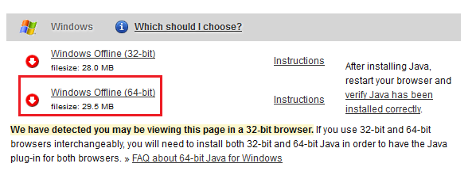

1. Install it with the defaults. This should install it to the “C:\Program Files\Java\jre7” folder (assuming 64 bit).
2. Once installed, create a system environment variable called “JAVA_HOME” with value “C:\Program Files\Java\jre7”. Note that this is the installation path.

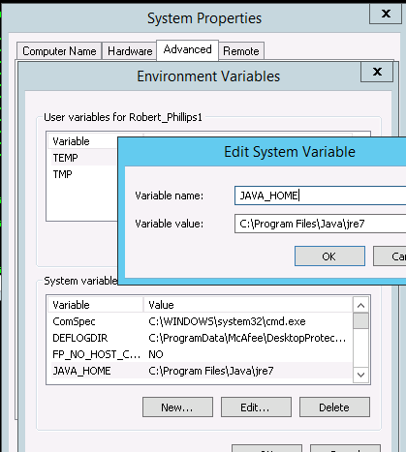

1. Obtain (or download) Elastic Search 1.2.1. Note that it is just a ZIP file. The URL is <http://www.elasticsearch.org/download/>. Note that the version is updated frequently.
2. Copy the root folder contained with the ZIP file to the desired local path. For example. Copy it to the E-drive.

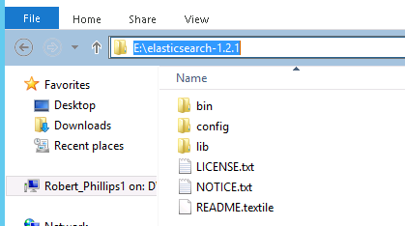

1. From the command line, navigate to the Elastic Search folder named “bin” and setup the Windows service using the service.bat file with the “install” option.

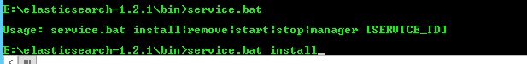

1. Elastic Search should now show up as a service. You probably want to set the Startup value to Automatic. TODO: Need to determine the proper account.



1. To run the instance as a standalone instance, update the configuration by editing the “elasticsearch.yml” file. For example, it would be located in the “E:\elasticsearch-1.2.1\config” directory. Make the following edits.
   1. Make a backup of the current configuration file and leave it in the same folder. For example, copy it to a file named “elasticsearch.yml.orig.”
   2. Uncomment the following settings and set values as:
      1. action.disable_delete_all_indices: true
      2. indices.fielddata.cache.size: 25%
      3. indices.cluster.send_refresh_mapping: false
      4. index.number_of_shards: 10
      5. index.number_of_replicas: 1
      6. discovery.zen.ping.timeout: 10s
      7. discovery.zen.ping.multicast.enabled: false
      8. discovery.zen.ping.unicast.hosts: ["*name of data node*", " *name of data node* "]
      9. discovery.zen.minimum_master_nodes:1
   3. Non-Production setup
      1. Uncomment “cluster.name” and assign a value of “PremierPlus[Env].” For example, assign a value of “PremierPlusDev1” for Dev1 environment.
      2. Uncomment “node.name” and assign the value to be the server name followed by _data suffix. For example, assign a value of “dv1vmpremes01_data”
   4. Production setup
      1. Each data center will have its own cluster
         1. For servers in PC1
            1. cluster.name:PremierPlusProdPC1
         2. For servers in S3B
            1. cluster.name:PremierPlusProdS3B

**NOTE**: This will be a dormant cluster. With future releases, application will start performing dual writes, and hydrate this cluster.

premier-ro.delldb should resolve to PC1 only.

* + 1. Master node
       1. Uncomment “node.name” and assign the value to be the server name followed by _master suffix. For example, assign a value of “P70VMPREMES01_master”
       2. Uncomment “node.master” and assign a value as “true”
       3. Uncomment “node.data” and assign a value as “false”
    2. Data node
       1. Uncomment “node.name” and assign the value to be the server name followed by _data suffix. For example, assign a value of “P70VMPREMES02_data”
       2. Uncomment “node.master” and assign a value as “false”
       3. Uncomment “node.data” and assign a value as “true”

1. Start the service and verify by navigating to <http://localhost:9200/_status>.

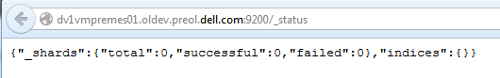

1. You can also look at status using the log files. For example, look in e:\elasticsearch-1.2.1\logs.
2. Install the Head tool so that you have a tool to review the status of the indexes. Note that this performs an install from github.

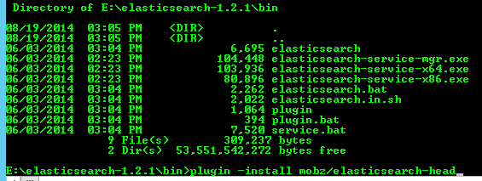

1. You can verify it at <http://localhost:9200/_plugin/head/>.

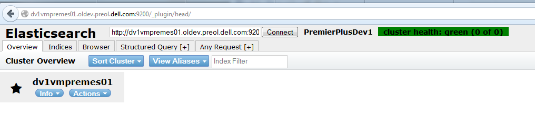

# Deployment and Verification Checklist

The following is a summary of items to verify to help facility the setup of a new environment.

1. Verify that servers are available. Use the information in the “Server Infrastructure” section in this document as a guide.
   1. Ping the server and verify that the IP address matches the IP address that was given.
   2. Use nslookup to verify DNS alias entries (if necessary).
   3. Verify that the DDrive share is available. You should see a folder named “logs” if the application has been deployed. Otherwise, it should be created when the application is deployed. For non-web applications, you application install folder should be here as well.
   4. Verify that the EInetpub share is available (if it is a web server).
2. Verify that the application components are aligned to the servers. This is done from the Home page of the Online Environment Ops dashboard. For example:
3. Select the “API” NSB Application under PremierPlus to navigate to the “application details” page.

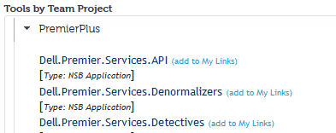

1. Expand the “Environment Information” section and ensure the servers listed are the correct deployment target of the application.

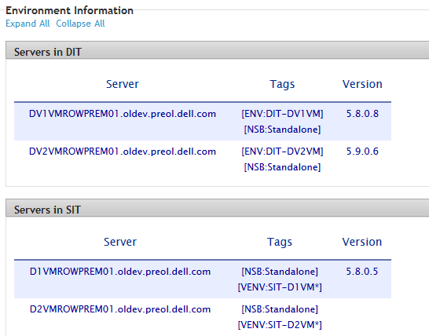

1. Verify that the Release-Nightly build is available. This is done via the Deploy page of the Online Environment Ops dashboard. For example:
2. Select the environment in which the deployment will be performed.

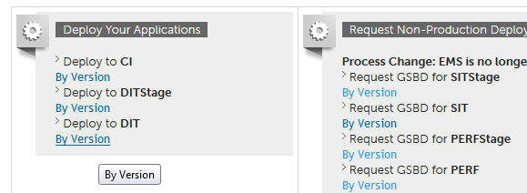

1. Select the environment, project and build. Note that the Release builds for each release should appear as a tab. Other build types should not be in this list. Contact GSBD if the build is missing.

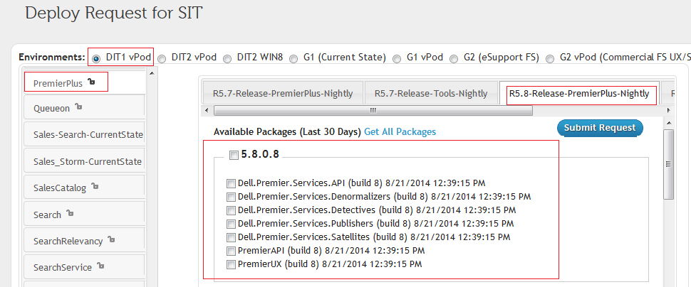

1. Select the application components you wish to deploy and click Submit Request.
2. For DEV, you can deploy immediately using the “Deploy” button on the subsequent screen. For other environments, the deployment has to be approved by and SDET on the team.
3. Verify that the application files are successfully deployed. This is done via the Deploy page of the Online Environment Ops dashboard.

You can also verify the files via the server’s D-drive or E-Drive share. Using a “diff” utility is handy for this task. For example “tf folderdiff” provided by TFS works well.

For example, in the following image, note the server name, the application, and the environment details (web site, virtual directory, application pool, and port) applied to the deployed application.

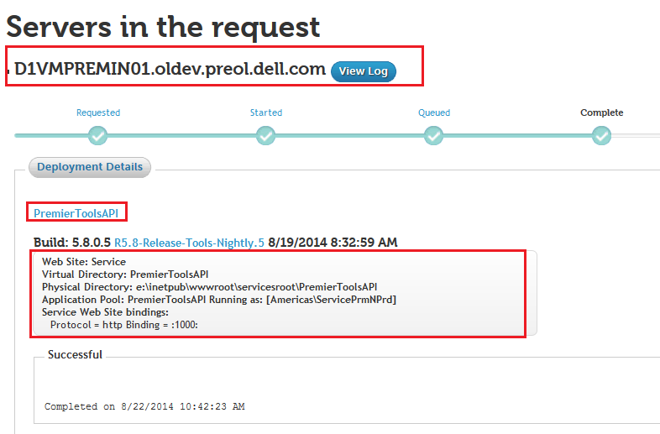

1. Verify that the databases are setup. Online Solutions Delivery performs database related tasks. Contact them for temporary access to the DBs.
2. Use SMSS to navigate to connect to the servers and browse the database objects. You can validate against the information the “Databases” section in this document.
3. Use a schema compare tool to compare a known good source to the server version of the DB. A known good source can be created locally using the scripts in source control.
4. Verify that Elastic Search is setup. This can be done using the steps noted in the “Elastic Search Setup” section in this document.
5. Verify setup in PremierCE database. This can be done using the information noted in the “Databases – Existing” section in this document.
6. Run the applications and verify the creation of the expected log files one the server (in d:\logs).